**North South University**

**Department of Electrical and Computer Engineering**

**CSE 215L: Programming Language II Lab**

**Lab** – **10: Inheritance & Polymorphism**

**Objective:**

* To understand inheritance
* To understand polymorphism



|  |  |  |
| --- | --- | --- |
| Plant |  | Flower extends Plant |
|  |  |  |
| - name: String |  | - hasSmell: boolean |
| - color: String |  | - hasThorn: boolean |
| /* constructor */ |  | /* constructor */ |
| /* accessor-mutator */ |  | /* accessor-mutator */ |
| /* toString */ |  | /* toString */ |

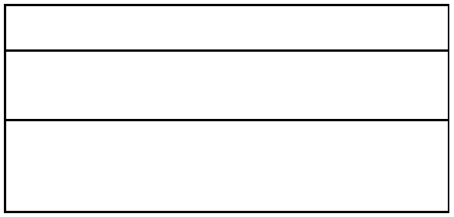

Herb extends Plant

* isMedicinal: boolean
* season: String

/* constructor */

/* accessor-mutator */

/* toString */

In main method, create an array of Plant objects and implement these methods: static void add(Plant [] plants, Plant p) // to add new plant object into the array static void remove(Plant [] plants, String n) // remove a plant given its name static Plant search(Plant [] plants, String n) // search for a plant given its name static void display(Plant [] plants) // display all Plant objects